2.2 Calculus of Vector-Valued Functions

Recall: A vector-valued function maps real numbers to n-dimensional vectors .
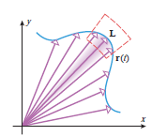

It is important to visualize how plots points via vectors.
We begin this section by looking at the limit of a vector-valued function.

Definition: Let be a vector-valued function that is defined for all t in some open interval containing the number a (it need not be defined at a). We write that
if and only if

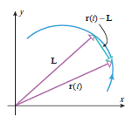
Note: It is important to see that the limit of is a vector L. L is often referred to as a limiting vector. Therefore, we don’t imagine we following points on the curve when we evaluate the limit of , but rather we are following the sequence of vectors since is a function that produces vectors.

The above definition suggests the following theorem.

Theorem: If , then we define as follows:

.

Proof: Omitted, but it follows from the above definition.

Definition: A vector function is continuous at a if

Theorem: A vector function r is continuous at a if and only if its component functions are continuous at a.

Proof: This theorem follows immediately from how continuity is defined for vector functions and how continuity is defined in calculus one for functions of the form .

Example 1: Consider the vector function .
- Find

- Is the function r continuous at 1? Give a brief explanation of your answer.

Definition: The derivative of a vector function r is defined by: .

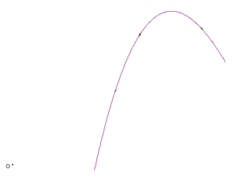
Intuitively, one can imagine that as h approaches 0 the vector in orange will approach the vector in green (which is tangent to the curve at the terminal point of ). This leads naturally to the following definitions.

Definition: Suppose that . The vector is called the tangent vector to the curve, C, defined by r at the terminal point, P, of the position vector .
The tangent line to C at P is defined to be the line through P parallel to .
Also, is called the unit tangent vector.

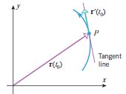
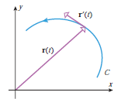

The next theorem gives us a familiar way to calculate .

Theorem: If and the component functions of r are differentiable then, .

Proof:

Note: There is nothing special in the above proof that requires the vector function to have 3 components. The same proof works for a vector function of the form .
Example 2: Consider
- Find

- Find

- Find parametric equations for the tangent line to the curve determined by r at the point .

Note: You can use the graphing software on Blackboard to help visualize what we have found in this example.

Theorem: Suppose and are differentiable vector functions, c is a scalar, and is a differentiable function. Then,

Proof: Many of these are left as practice in the exercises for this section.

Note: With the exception of property 5 all of the above properties hold when u and v have two or more component functions.
Theorem: If is a differentiable vector-valued function in 2-space or 3-space and is constant for all t, then

that is, and are orthogonal vectors for all t.

Proof:

Definition: The definite integral of a continuous vector function is .

Note: For now we will hold off on a physical interpretation of the definite integral (we will see a nice application for it in 2.6). The indefinite integral is defined similarly.
Example 3: Suppose . Find (exactly).

Note: Again, it is important to see that our result is a vector.

